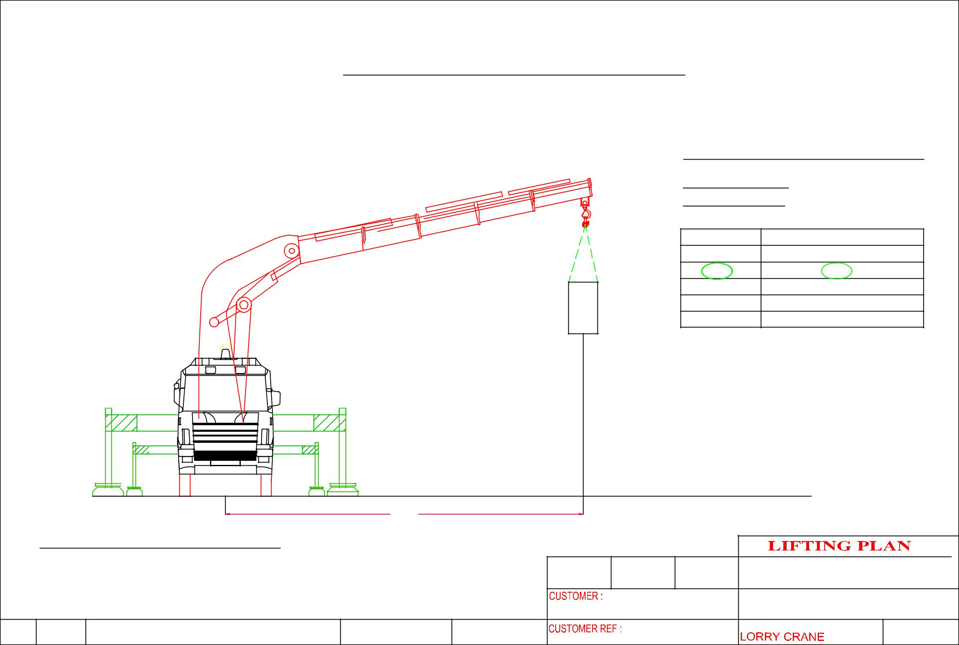
 |  |  | HOISTING OF MACHINE @ 259 Jalan Ahmad Ibrahim
 |  |  |  |  |  |  |  | CRANE: PALFINGER PK100002F
 |  |  |  |  |  |  |  | LORRY CRANE
 |  |  |  |  |  |  |  | CRANE CONFIGURATI0N
 |  |  |  |  |  | m6 |  | OPERATING RADIUS : 6m
 |  |  |  |  |  |  |  | ^{OPT . RADIUS(m)} |  | LIFTING CAPACITY OF CRANE IN KG
 |  |  |  |  |  |  |  | 4 |  |  | 20, 100
 |  |  |  |  |  |  |  | 6 |  |  | 14,300
 |  |  |  |  |  |  |  | 8 |  |  | 10,700
 |  |  |  |  |  |  |  | 10 |  |  | 8,300
 |  |  |  |  |  |  |  | 12 |  |  | 6,600
 |  |  |  |  | MACHINE WEIGHT: | 11,000  KG |  | SAFETY FACTOR CALCULATION
 |  |  |  |  |  |  |  | WEIGHT OF CARGO |  |  | : 11,000KG
 |  |  |  |  |  |  |  | LIFTING ACCESSORIES WEIGHT : 50 KG
 |  |  |  |  |  |  |  | TOTAL WEIGHT OF LIFTING |  |  | : 11,050KG
 |  |  |  |  |  |  |  | LIFTING CAPACITY |  |  | :14,300 KG
 |  |  |  |  |  |  |  | SAFETY FACTOR |  |  | : 1,29
 |  |  |  | 6M
 | CRANE: PALFINGER PK110002SHH
 |  |  |  |  |  | DRAWN | APPROVED | DATE | ERIC WONG MACHINERY TRANSPORTATION P/L
 |  |  |  |  |  |  | VDL |  | DRAWING NAME:
 |  |  |  |  |  |  |  |  | HOISTING OF MACHINE

